**Log book**

31/7/2019

Bob completed some coding for arithmetic and geometric sums (code planning). Rickey worked on creating the Documentations needed for the project:

* Project definition
* Gantt Chart
* Logbook
* Context and data flow diagram
* 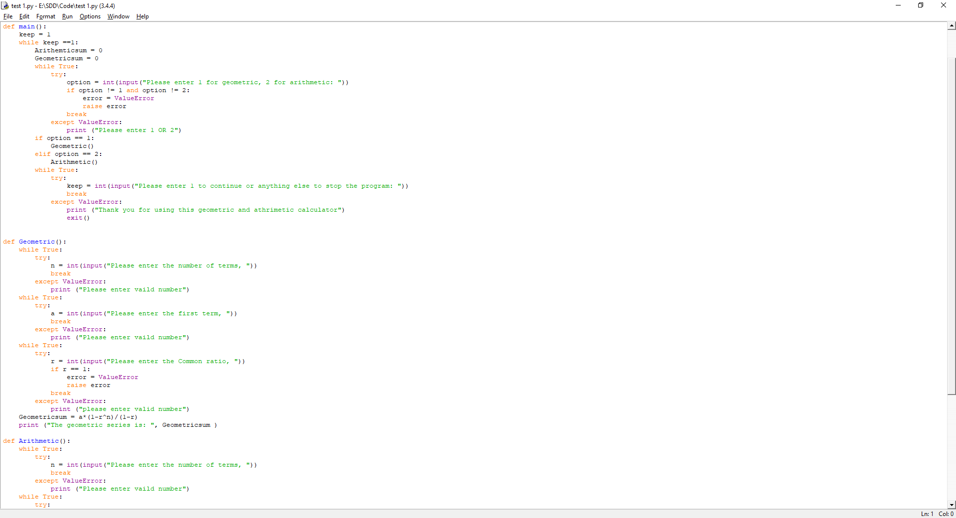Structure chart and Data dictionary

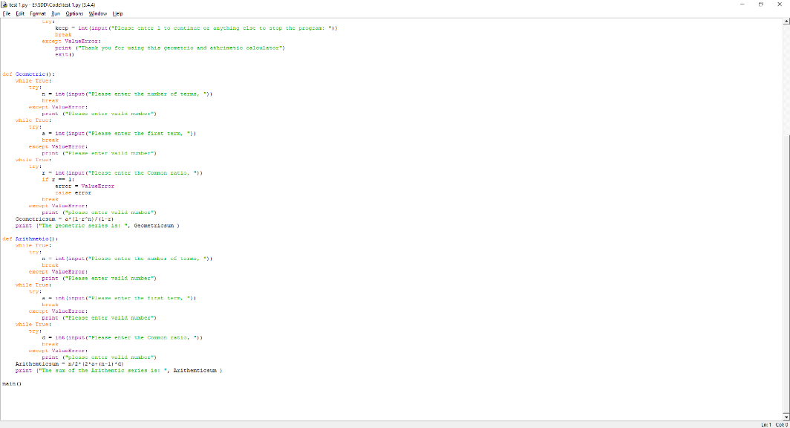

1/8/19

Bob did more code and Rickey worked on project definition.

2/8/19

Bob was away. Rickey worked continued on the project definition.